Parents Meeting: Set 2 and 3 Sounds

What can you do to help at home?

- Practise the sounds and phrases
- Practise reading sounds speedily - ‘review, review, review’
- Use ‘Special Friends’, ‘Fred Talk’, read the word’ to read words.

There are free video tutorials on our website – www.ruthmiskin.com

Select ‘Find out more’ at the top, then ‘Parents’ from the drop-down list:

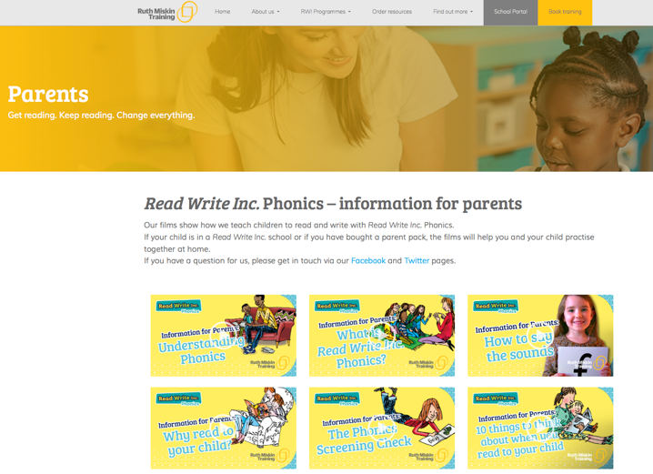

We’re also on Facebook – www.facebook.com/miskin.education

Free e-books for home reading:
http://www.oxfordowl.co.uk/Reading/

